CSA06507-Generative AI
Lab Experiment’s
.
Unit 2: Lab Programs for Prompting
Experiment 10: SQL Query Generation Using Structured Prompting
Aim:
To design structured prompts that provide database schema, table details, and requirements to a Large Language Model (LLM) to generate appropriate SQL queries and execute them to retrieve the required information.
Algorithm
- Start the program.
- Create a database using SQLite.
- Create a table named Students with student details.
- Insert sample student records into the table.
- Design a structured prompt containing the database schema and query requirements.
- Generate SQL queries based on the given requirements.
- Execute the SQL queries using Python.
- Retrieve and display the results.
- Validate the generated SQL queries.
- Stop the program.
Python Program
Python
Run
import sqlite3

# Step 1: Create database
conn = sqlite3.connect(":memory:")
cursor = conn.cursor()

# Step 2: Create Students table
cursor.execute("""
CREATE TABLE Students (
ID INTEGER,
Name TEXT,
Department TEXT,
Marks INTEGER
)
""")

# Step 3: Insert records
students = [
(1, 'Ravi', 'ECE', 85),
(2, 'Priya', 'CSE', 92),
(3, 'Kiran', 'ECE', 78),
(4, 'Anu', 'CSE', 88),
(5, 'Rahul', 'EEE', 75)
]

cursor.executemany(
"INSERT INTO Students VALUES (?, ?, ?, ?)",
students
)

# Step 4: Structured Prompt
prompt = """
Database: Student Database

Table: Students

Input
The sample database contains the following student records:
ID | Name | Department | Marks
1 | Ravi | ECE | 85
2 | Priya | CSE | 92
3 | Kiran | ECE | 78
4 | Anu | CSE | 88
5 | Rahul | EEE | 75
Output
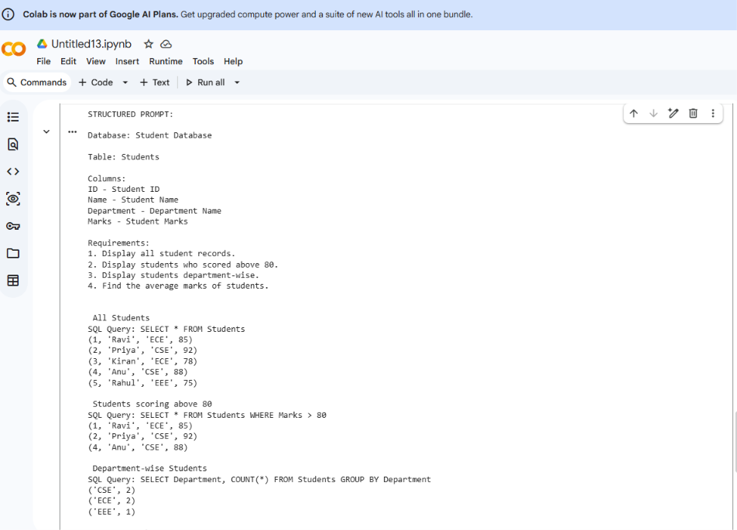
Result
Thus, SQL query generation using structured prompting was successfully implemented in Google Colab using Python and SQLite. A structured prompt was designed with database schema, table details, and query requirements. Appropriate SQL queries were generated, executed, and validated successfully with the expected results.
ChatGPT can make mistakes. Check important info.

